Since 1980s, robotics has found a new domains : Surgery and medicine. The robots must be reliable, clean and not cumbersome. In medicine, the robots are used because they can do a lot of things more precisely and quickly. The first robots which appeared Puma 260 (neurosurgery), Scara (orthopedic), Speedy (imaging and modelisation) and Puma 560 (surgery).

Robots are used in different fields:

* **Surgical Precision**

These robots have a better precision than the humans. They can make smaller accurate incisions where human cannot have access. Surgeons can still control the robots during the surgery.

* **Robotic Assistance**

We can control a robot with a remote control. It can interact with their patients, check on their living conditions.

Thanks to it, doctor can reduce the number of home visits.

**Social issue :**

People don’t have complete confidence towards robots :

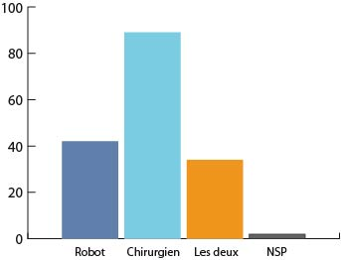

The evolution of robots will increase the number of unemployment ?

**Ethical :**

If the machine arm has a problem and hit someone, who have wrong ? The arm or the person ?